3CD Mathematics Specialist WACE Revision

3D Vectors
Questions are taken from VCE Secondary Papers

2009

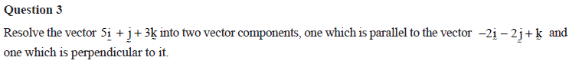

Answers
3.

2008
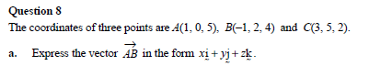

Answers
8. a.
b.
c. Show ONE pair of adjacent sides are at right angles OR show that diagonals have the same length.

2007
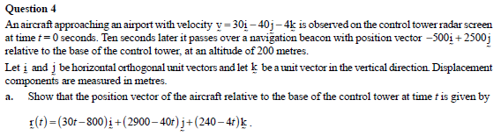

Answers
4. a.
b.
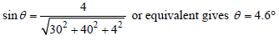
c.
d.
e.

